Wig Stand Design Notes

Materials…
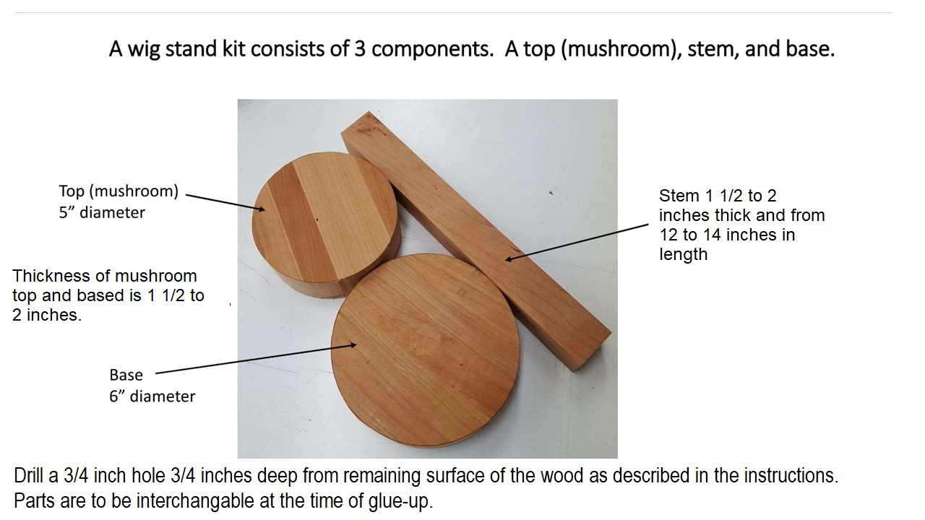

Education Class Approach
We will spend the morning on the ‘stem’ of the wig stand (spindle orientation) and the afternoon on the base and ‘mushroom’ top which are much simpler side-grain turnings.
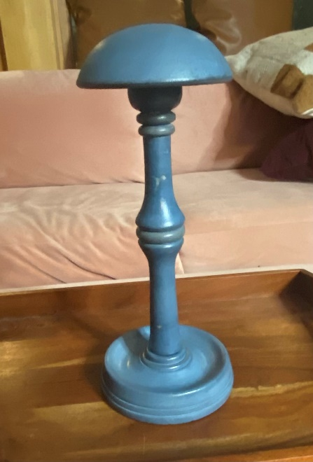 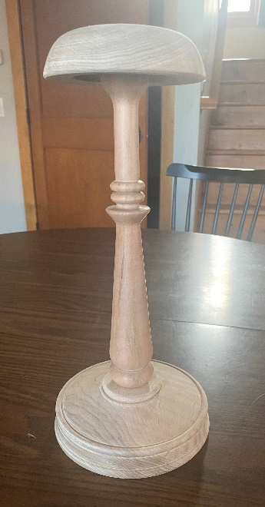 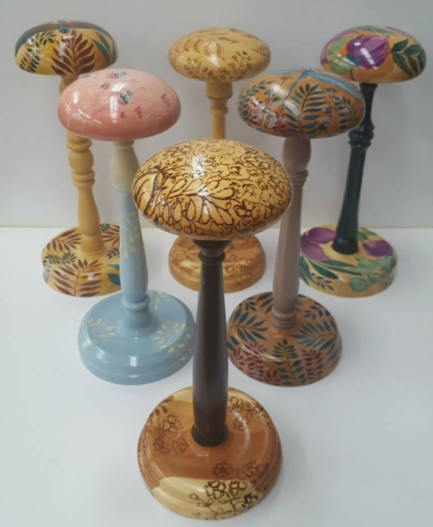
Fun YouTube video from Richard Raffan published May 1st on turning a wig stand Link to video, our approach will be a little different in some ways but very similar in others.

Turning the stem for the wig stand
Your spindle blank will be 12 inches long. The charity would like the wig stand to be between 12 to 16 inches tall and ours should be around 14 inches in total height when complete.
We will mount the spindle blank between centers and turn it round using the spindle roughing gouge.
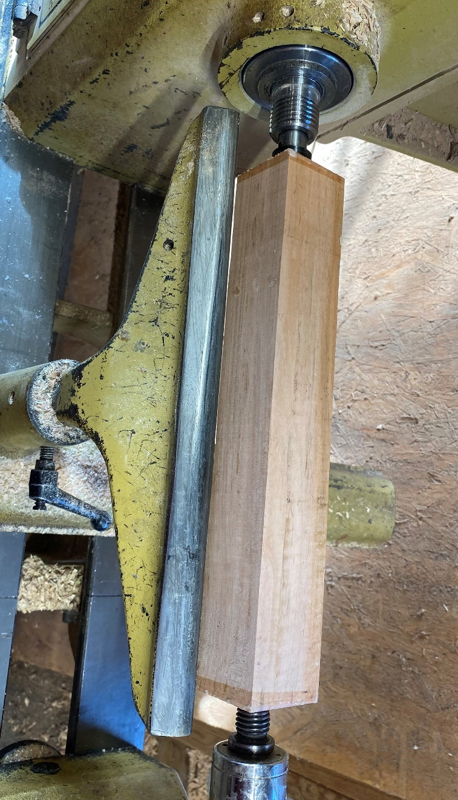
Next, we’ll turn an accurate ¾ inch tenon ¾ inches long on both ends of the spindle blank. To turn an accurate tenon you will need a caliper of some sort to help you get it sized right, do NOT trust your eyes on this. The ‘helpers’ in the room will have one of the following handy for you to use; traditional caliper, vernier caliper or a simple ¾ inch open end wrench.
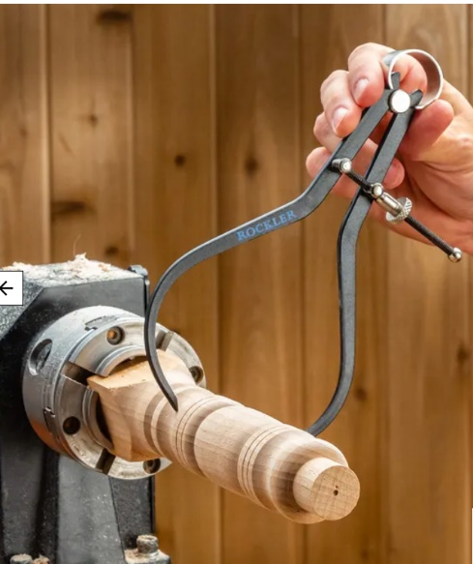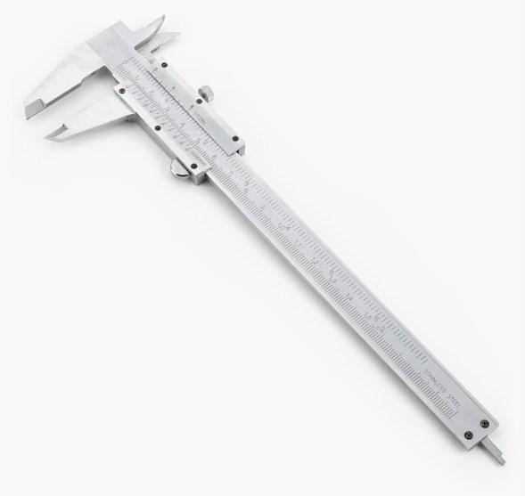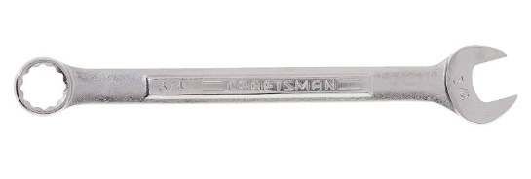

Design time… have a plan. Many people ‘layout’ the major cuts and use a parting tool to size the marked area to the diameter of their design at that point to help guide them as they cut the beads, coves and various curves and flats of their spindle.
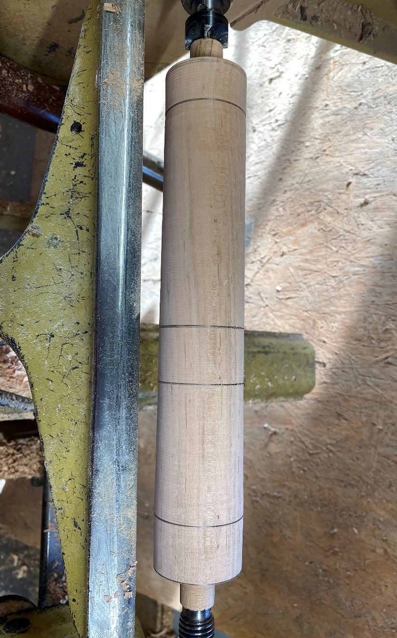
To turn the tenons and the design of your stem you will use some combination of the following tools. If you don’t own one of these there will be tools to borrow during the class:
- Parting tool – to do the layout (thin parting tool) discussed above and on the tenon (wider parting tool) if not using the skew.
- Skew chisel – peeling and scraping cut on the tenon and planing cuts of the big curves and flats.
- Spindle gouge – beads and coves on the spindle, both ½ inch and 3/8 inch are handy on this project, you will probably not need a smaller spindle gouge or ‘detail’ spindle gouge for this project. You could use bowls gouges if you don’t have spindle gouges for many aspects of your stem but a bowl gouge will not cut many types of beads very well.
- Beading tool – really not a ‘cheat’ very handy for beginning turners. I have a video of grinding one of these from an old bowl gouge on my John Thorson Woodturning Facebook page.
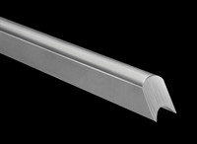
This is a popular beading tool available from D-Way Tools.

We will sand but not put a finish or paint on all our wig stand parts at this time. To sand, we will go through the grits from 80 (if necessary) to 120 to 180 to at most 220 – we don’t want to burnish the wood which will complicate staining etc.
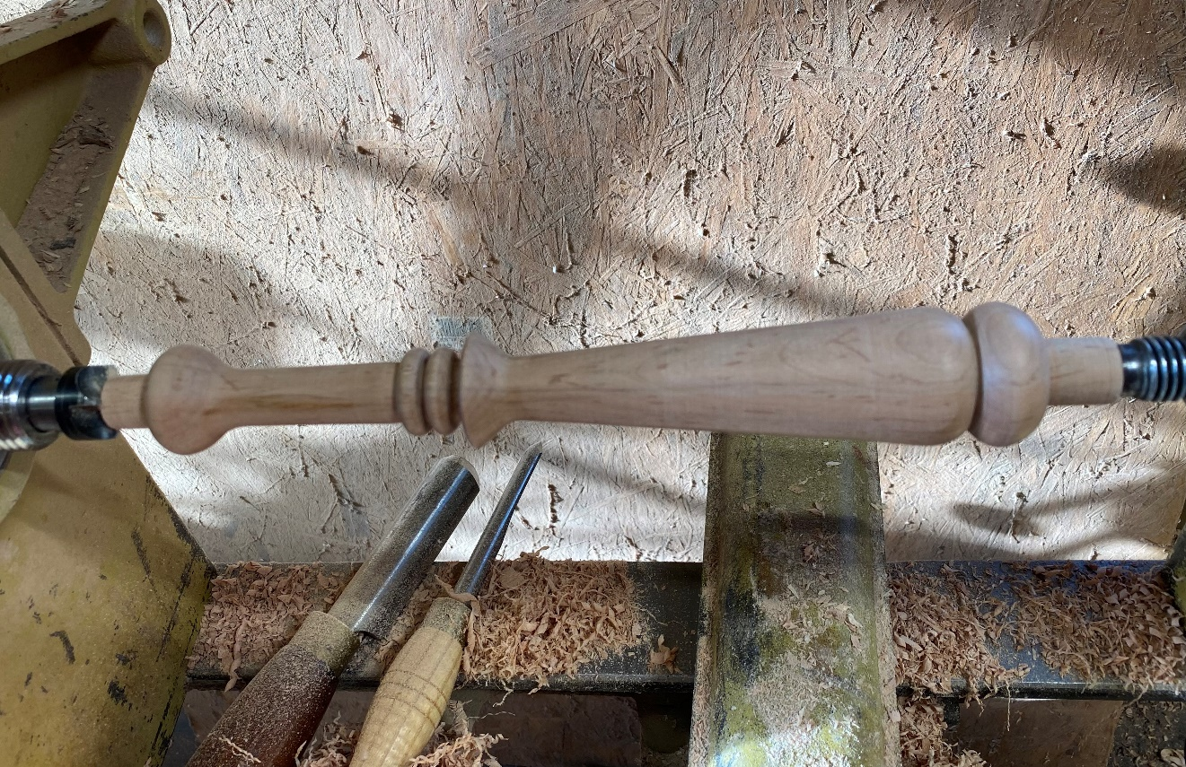

Turning the ‘mushroom’ top and base
The blanks are side-grain turnings and you can use your spindle gouges or a bowl gouge for this work. We will discuss the ‘why’ on that statement in the class.
Spindle gouge, ground to the center of the bar Bowl gouge, deeper flute to clear chips etc.
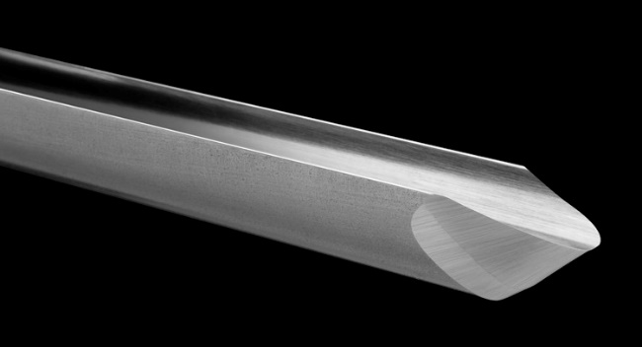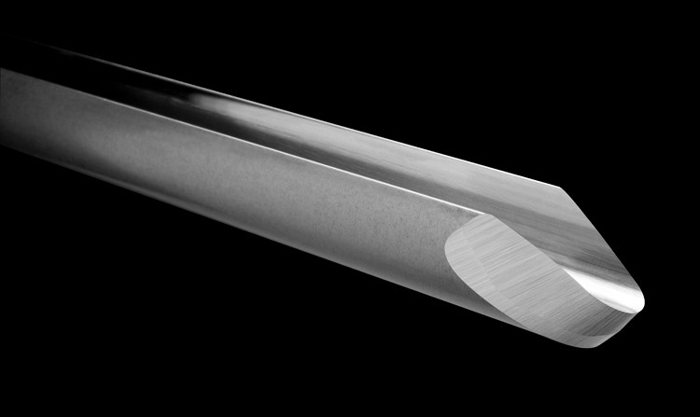
You can see how the spindle gouge will be able to turn ‘tighter’ beads before those wings on the flute make contact with the bead next to it. The bowl gouge on the other hand would not change directions as quickly due to the bottom of the flute being closer to the tool rest support, a good thing for a bowl surface or a bigger bead or cove or a long planning cut but not good for small beads, etc.

Turning a tenon between centers
Once you have marked the center of your side-grain blank (for the mushroom top or the bottom of the stand) you can mount the blank between a spur drive center and live center on the lathe. Turn an accurately sized tenon for the chuck jaws you will be using. More on this during the class.

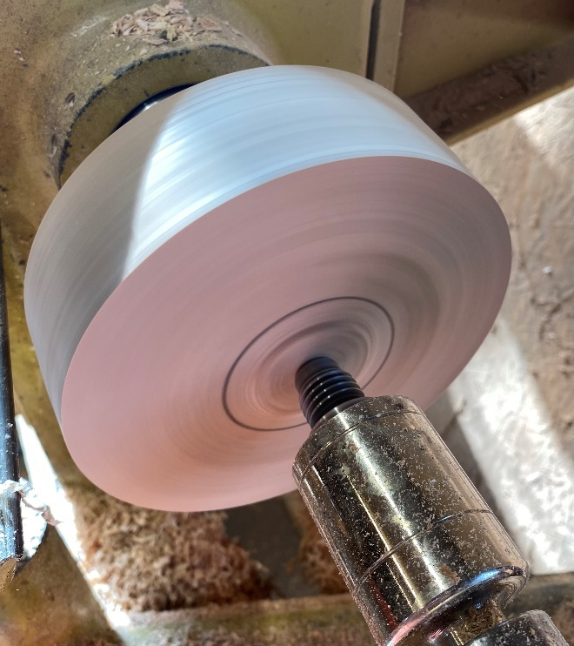

Turning a tenon when using a screw chuck
For the OneWay screw in the VicMarc 120 chuck drilling a 3/8 inch hole 1 inch deep would be required. We only want to drill ¾ of an inch deep so a spacer is used as shown in the photo below. We now have easy access to turn the tenon.

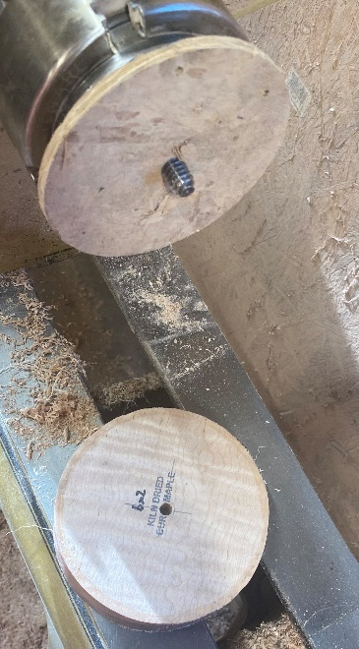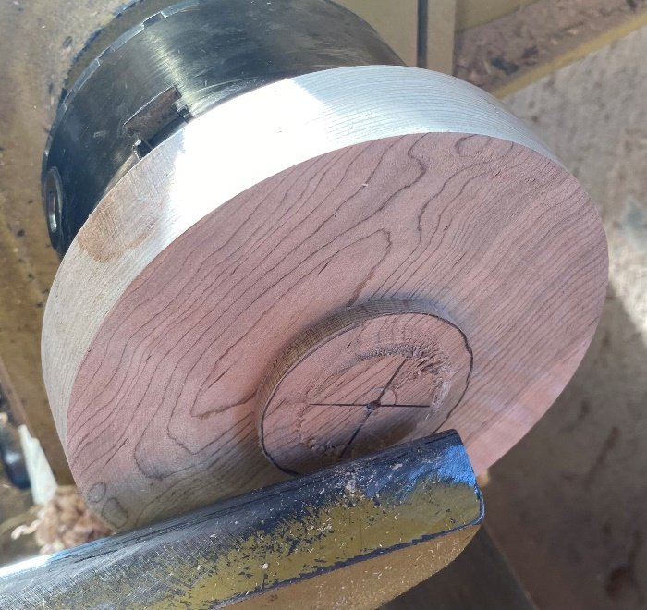

Reversing the blank by holding it in the 4-jaw chuck by the tenon and then turning the recess and drilling the stem mounting hole in the ‘bottom’ of the mushroom top…
Here we are holding the mushroom top by the tenon we’ve turned in its top.

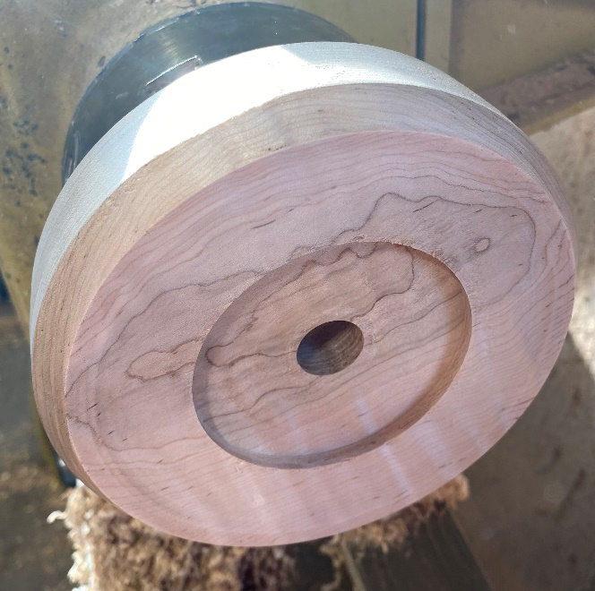

On the bottom of the mushroom top we will ‘face off’ the surface (making it flat) before relieving that surface a bit and then turning a recess for the chuck jaws to grab. This recess must be accurately sized to the outer diameter of the chuck jaws you will be using. Once this is completed you will drill your ¾ inch diameter hole to an accurate ¾ inch depth (in the mushroom top only, base will have this hole on the top side).
You will use your spindle gouge or bowl gouge primarily for the mushroom top and will use a skew to get accurate mating surface for the chuck jaws (more on this in the class). To drill the hole for the stem we will be using a Forstner bit in a Jacobs chuck held in the tailstock. The depth can be determined by putting tape on the bit or using the markings on the tail stock quill.
You will sand this surface removing all sharp edges and get it ready for finish. We don’t want to ‘catch’ the wig’s hair or cut a finger! Once you turn away the tenon in the next step you will not be able to come back to work on this surface so it must be in ready-to-finish state, no sharp edges, when this step is complete.
Richard Raffan removed ‘weight’ from the mushroom top in his video, this is a bit complex for new turners and so we will not be going to this extreme with our wig stands.

Reverse the mushroom top by holding in the recess in the bottom to turn the upper surface to match the curve of an ‘average’ skull
To turn the top of the mushroom we will hold it securely in the recess we turned for the chuck jaws we are using.
Right, curve of an ‘average’ skull… easier said than done. You can see in the first photo that I got too much curve in my first attempt on the mushroom top. We have to be careful, the wig will ‘take a set’ if sitting on the stand too long and we don’t want to create a ‘hump’ or a ‘bump’ in the wig!
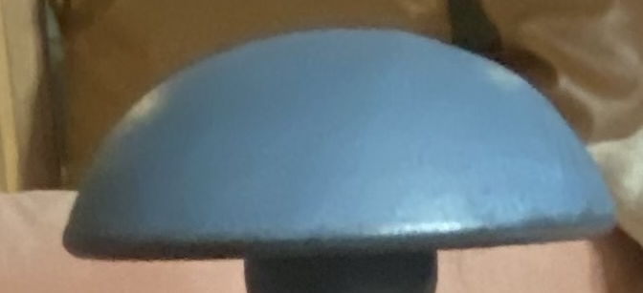
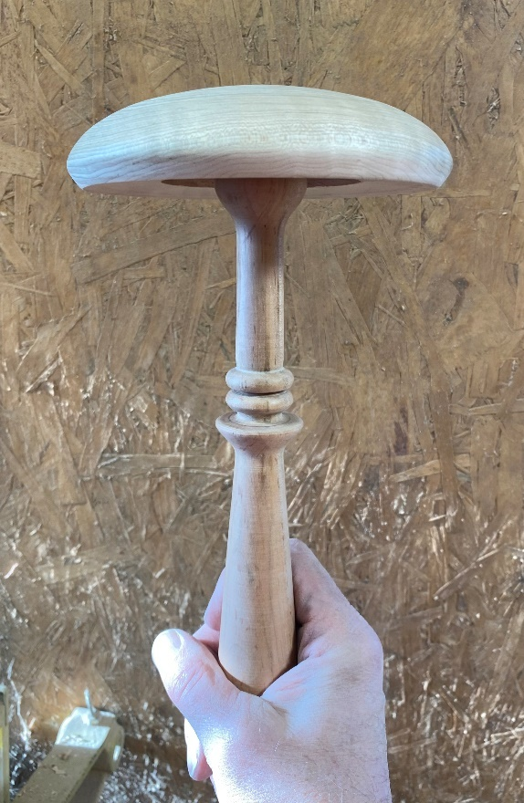
I did a bit better job of it in my second attempt…
I can just imagine all of you feeling the top of your head as you turn this part of the wig stand.
Don’t worry, we all do it. Richard Raffan used a ‘wire’ to measure his skull in that YouTube video mentioned on page one. He said he was making his wig stand for a Barrister’s wig… is he a lawyer? The end result was a bit large he had to admit, funny stuff!

Reversing the blank and turning the ‘top’ of the base
Earlier we used a screw chuck to hold the blank in this example as we turned a recess and finish sanded its bottom. We are now holding the base by that recess as we turn the ‘top’ of the base. NOTE: we DO NOT drill the bottom of the base, the stem mounting hole gets drilled now as we turn the TOP of the base!
Once we ‘face’ off the blank (make it very flat) we can drill hole for the stem. The mating surface between the mushroom top and the base must be very flat or just a little recessed to cleanly mate the two surfaces. The smaller hole drilled into the blank for the screw chuck mounting will now be re-drilled larger to be our ¾ inch diameter by ¾ inch deep hole for the stem.
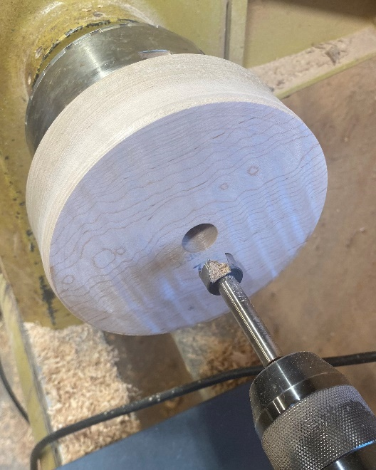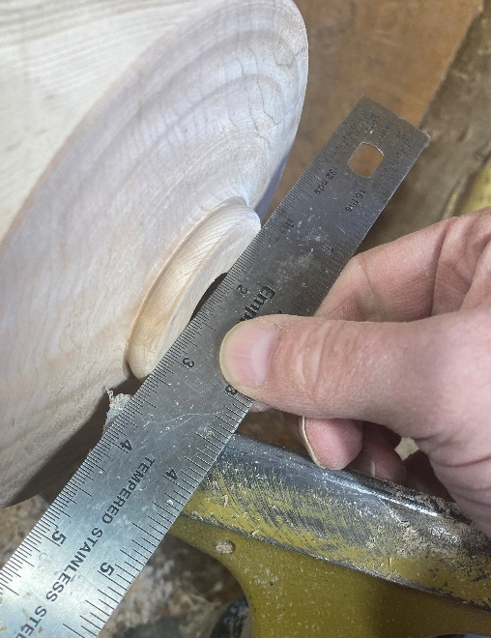

Design of the base
You will see in the following example wig stand base turnings that many people create a place to hold items related to wearing the wig or just for earrings, etc. (blue stand on the left). I forgot to do this in my second example on the right… good grief!
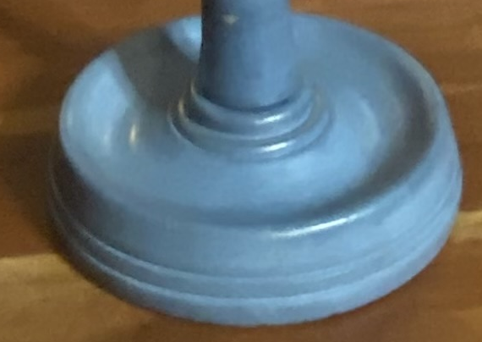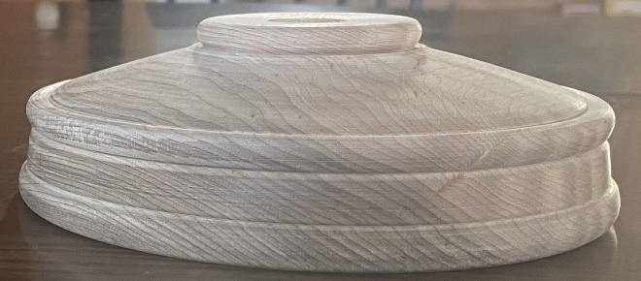

The stand parts ready for a urethane finish, as requested by the charity, even if the stand is painted it gets a urethane finish.
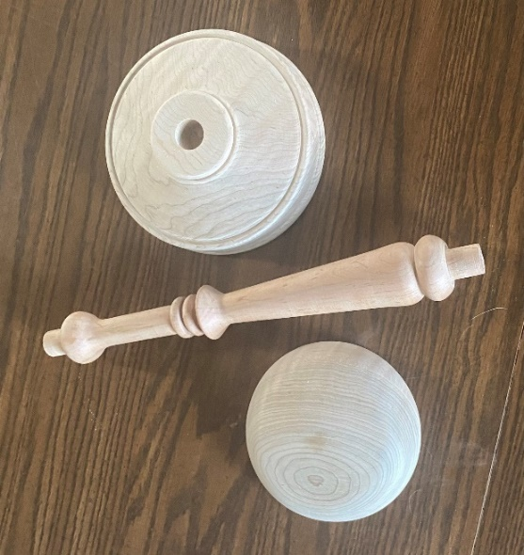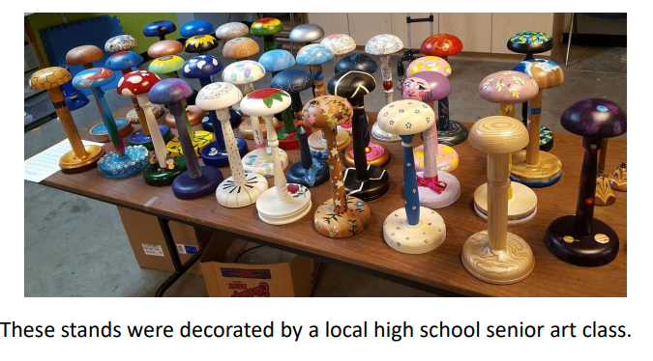
Other example designs on the AAW website the ‘how to turn a wig stand’ article is a bit of a different method than we will use in this class.
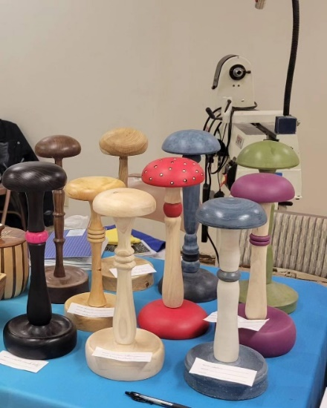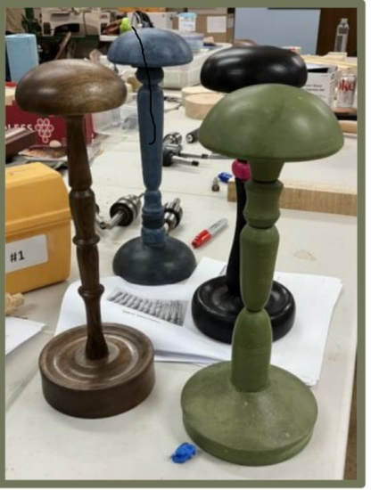

Design Sheet
Mushroom Top (right half only) Stem 3/4” to 1” Scale

Base (right half only)

